|  |
| --- |
| Invoke VLC media player from command line to play a Video  C:\Users\Bhuvanesh\Pictures\wmplayer.PNG |

|  |
| --- |
| Install Notepad++ and open notepad++ just by executing the command n or n.exe to create a new file called myContacts.txt |

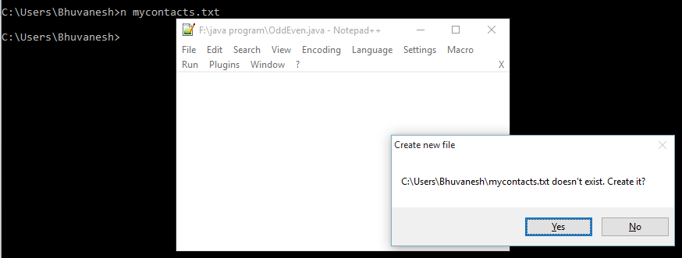

|  |  |  |
| --- | --- | --- |
| Install JDK 1.8 and setup path & JAVA_HOME environment variable  C:\Users\Bhuvanesh\Pictures\env var.PNG  **// Addition of two numbers**    class Add {  public static void main(String[] arg) {  int a=523, b=145, c;  c=a+b;  System.out.println("addition of two no's =" + c);  }  }    // Op: addition of two no's =668      **//Find Area of a Circle**    class Circle {  public static void main(String[] arg) {  float PI = 3.14F;  byte r = 5;  float area;  area = PI * r * r;  System.out.println("Area of a Circle=" + area);  }  }        // Op: Area of a Circle=78.5  **// WTP to print "Hello Felight" to Console (command line)**  class HelloFelight {  public static void main(String[] arg) {  System.out.println("Hello Felight");  }  }      // Op: Hello Felight  **What is the amount of memory consumed by Char data type?**  Ans: 2 bytes (16bit)    **int num = 128;**  **byte b =(byte) num;**    Ans: byte data type range is -128 to +127  Value 128 falls outside the range, so it goes to the otherside of the range and print negative no.  Op: -128. num = 130; b= -126    **System.out.println(1 -0.1-0.1-0.1-0.1-0.1);**  **0.5000000000000001**  **Why this much of no’s after decimal point?**  Ans:  Int value store with exact binary rep in memory but float and double are not like that.  Using BigDecimal class to solve this.    **//Find Area of a Circle**    class Circle {  public static void main(String[] arg) {  float PI = 3.14F;  byte r = 5;  float area;  area = PI * r * r;  System.out.println("Area of a Circle=" + area);  }  }    // Op: Area of a Circle=78.5    **// Convert Fahrenheit to Celsius and vice versa**    class TempConv {  public static void main(String[] arg) {  float temperature = 68;  temperature = ((temperature-32)*5)/9;  System.out.println("Temperature in Celsius =" + temperature);    temperature = ((temperature*9)/5)+32;  System.out.println("Temperature in Fahrenheit =" + temperature);    }  }    /* Op: Temperature in Celsius =20.0  Temperature in Fahrenheit =68.0 */      **/* Execute below statements and print the value of b &i in console.**  **inti = 129;**  **byte b = (byte) i; */**    class PrintValuesInConsole {  public static void main(String[] arg) {  int i=129;  byte b=(byte) i;  System.out.println("i=" + i);  System.out.println("b=" +b);  }  }  /* Op: i=129  b=-127 */     |  | | --- | | **How do you represent a binary number and an octal number in Java. Give examples** | | Binary number must starts with “0b” and contains only 0 and 1. |   Octal number consists of any combination of digits from 0 to 7 with leading 0**.**  **Examples:**  Int binary1 = 0b010; int binary2 = 0b100  Int octal1 = 012; int octal2 = 014;    **//Find the Unicode of #, $,%, 6**    class UnicodeForSymbol {  public static void main(String[] arg) {  int ch1 ='#';  int ch2 ='$';  int ch3 ='%';  int ch4 ='6';  System.out.println("Unicode for # $ % 6 = "+ch1+" "+ch2+" "+ch3+" "+ch4);  }  }      **//Find the Unicode for all 26 characters in English alphabet**    class Unicode {  public static void main(String[] arg) {  int var;  System.out.println("Unicode of English Alphabet (Upper Case)");  for(var='A';var<='Z';var++)  System.out.print(var+" ");  System.out.println();  System.out.println("Unicode of English Alphabet (Lower Case)");  for(var='a';var<='z';var++)  System.out.print(var+" ");  }  }      **//Write a program to perform addition of two octal numbers**    class OctalAdd {  public static void main(String[] arg) {  int oc1 =012, oc2 =07, oc3;  oc3 = oc1+oc2;  System.out.println("add of two binary no " +Integer.toOctalString(oc1)+ " and " +oc2+ " = "+oc3);  }  }    **//Write a program to perform addition of two binary numbers.**    class BinAdd {  public static void main(String[] arg) {  int b1 =0b011, b2 =0b101, b3;  b3 =b1+b2;  System.out.println("add of two binary no " +b1+ " and " +b2+ " = "+b3);  }  }      **//WTP To find a year is leap year or not**    class LeapYear {  public static void main(String[] arg) {  short y = 2012;  if(y%4==0) {  System.out.println("given year is leap year");  }else {  System.out.println("given year is not leap year");  }  }  }  //Op: given year is leap year    **//WTP to find number is even or odd**  class OddEven {  public static void main(String[] arg) {  byte n=3;  if(n%2==0) {  System.out.println("No is Even");  }else{  System.out.println("No is Odd");  }  }  }    //Op: No is Odd    **//WTP to find if the number is palindrome or not**    class Palindrome {  public static void main(String[] arg) {  int rem,n=121,rev=0;  int temp=n;  while(temp!=0) {  rem =temp%10;  rev =(rev*10)+rem;  temp/=10;  }  if(rev == n) {  System.out.println("no is palindrome");  }else {  System.out.println("no is not palindrome");  }  }  }    //Op: no is palindrome    **//Print all the even number between 0 to 100 using while loop.**    class EvenNo {  public static void main(String[] arg) {  byte i=0;  System.out.println("Even no between 1 to 100 ");  while(i++ <= 100) {  if(i%2 == 0)  System.out.print(i+" ");  }    }  }    **//Print all the odd number between 100 to 200 using do While loop**    class OddNo {  public static void main(String[] arg) {  short i=100;  System.out.println("Odd no between 100 to 200 ");  do{  if(i%2 != 0)  System.out.print(i+" ");  i++;  }while(i<=200);  }  }      **//WTP to print even numbers between 1000 to 1020**    class EvenNoForLoop {  public static void main(String[] arg) {  short i;  System.out.println("Even no between 1000 to 1020 "); {  for(i=1000; i<=1020;i++) {  if(i%2 == 0)  System.out.println(i+" ");  }  }  }  }      **//WTP to print odd numbers between 500 to 600**    class OddNoForLoop {  public static void main(String[] arg) {  short i;  System.out.println("Odd no between 500 to 600 "); {  for(i=500; i<=600;i++) {  if(i%2 != 0)  System.out.print(i+" ");  }  }  }  }      **//WTP to check if number is prime or not**    class PrimeNo {  public static void main(String[] arg) {  short i,n= 17;  for(i=2;i <= n/2-1;i++) {  if(n%i==0)  break;  }if(i==n/2)  System.out.println("The no " +n+ "is prime no");  else  System.out.println("The no " +n+ "is not prime no");  }  }    **//WTP to check if the number is divisible by 6**    class DivBy6 {  public static void main(String[] arg) {  short n= 81;  if((n%2==0)&&(n%3==0))  System.out.println("The no " +n+ " is divisible by 6");  else  System.out.println("The no " +n+ " is not divisible by 6");  }  }      **//WTP to print prime number between 100 to 200**    class PrimeNumb {  public static void main(String[] arg) {  short i,n;  System.out.println("Prime Number between 100 to 200");  for(n=100;n<=200;n++) {  for(i=2;i <= n/2-1;i++) {  if(n%i==0)  break;  }if(i==n/2)  System.out.print(n+" ");  }  }  }      **//WTP to print number between 100 to 200 which are divisible by 6**    class PrintNoDivBy6 {  public static void main(String[] arg) {  short i,n;  System.out.println("Number between 100 to 200 which is divisible by 6");  for(n=100;n<=200;n++) {  if((n%2==0)&&(n%3==0))  System.out.print(n+" ");  }  }  }        **//WTP to print Fibonacci series**    class Fibonacci {  public static void main(String[] arg) {  int first =0, second =1, n=20,i;  System.out.println("The first " +n+ " fibonacci no's are");  System.out.print(first+" "+second+" ");  for(i=2;i<=20;i=i+2) {  first =first+second;  second =first+second;  System.out.print(first+" "+second+" ");  }  }  } |

